[Yashwantrao Chavan Maharashtra Open University](http://ycmou.digitaluniversity.ac/)

A

PROJECT REPORT

ON

**“QuickMove Packers and Movers”**

Submitted By

MR. SHAIKH SHAHBAZ BILAL AHMED

MR. ANSARI SHAHEBAZ AHMAD ATIQUZZAMA

MR. SHAH HUZAIFA ABDULHAMEED

BCA (2019-2020)

**RAIS HIGH SCHOOL CAMPUS OF KOKAN MUSLIM EDUCATION SOCIETY (35226)**



PROJECT

ON

QuickMove Packers and Movers

In the Subject

BCA (Bachelor of Computer Application)

A project Submitted to the

[Yashwantrao Chavan Maharashtra Open University](http://ycmou.digitaluniversity.ac/)

In partial Fulfillment of

The Requirement

Of

B.C.A (Bachelor of Computer Application)

BY

SHAIKH SHAHBAZ BILAL AHMED PRN=2016017000747552

ANSARI SHAHEBAZ AHMAD ATIQUZZAMA PRN= 2016017000747536

SHAH HUZAIFA ABDULHAMEED PRN=2016017000773986

UNDER THE GUIDANCE

PROF.HINA MOMIN

DEPARTMENT OF B.C.A

**Academic Year 2019-2020**

**ACKNOWLEDGEMENT**

We thank the almighty for giving us the courage & perseverance in completing the project. This project itself is an acknowledgement for all those who have given us their heart-felt-co-operation in making it a grand success.

We are thankful to our principal, **Prof. Mr. Chandrashekhar Pardeshi** for providing the necessary infrastructure and labs. We are greatly indebted to, Head of Information Technology, **Mr. Chandrashekhar Pardeshi** for providing valuable guidance at every stage of this project work.

We are also thankful to the coordinator, **Ms. HINA MOMIN** for extending their sincere & heartfelt guidance throughout this project work. Without their supervision and many hours of devoted guidance, stimulating & constructive criticism, this thesis would never come out in this form.

It is a pleasure to express our deep and sincere gratitude to the project Guide **Ms. HINA MADAM** and is profoundly grateful towards the unmatched help rendered by him. Our special thanks to all the lectures of Information Technology, for their valuable advises at every stage of this work

Last but not the least; we would like to express our deep sense and earnest thanks giving to our dear parents for their moral support and heartfelt co-operation in doing the project. We would also like to thank our friends, whose direct or indirect help has enabled us to complete this work successfully.

**INDEX**

|  |  |  |  |
| --- | --- | --- | --- |
| Sr no. |  | Title | **Page no.** |
| 1 |  | Introduction | **1** |
|  | 1.1  1.2  1.3 | Background  Objectives  Purpose and scope | **2**  **2**  **3** |
| 2 |  | Survey of Technology | **4** |
| 3 |  | System Analysis | **7** |
|  | 3.1  3.2  3.3  3.4  3.5  3.6 | Existing system  Proposed system  Requirement analysis  Hardware Requirement  Software Requirement  Justification of selected technology | **8**  **9**  **10**  **12**  **13**  **14** |
| 4 |  | System Design | **15** |
|  | 4.1  4.2 | Database table  Data dictionary | **15**  **16** |
|  | 4.3  4.4  4.5  4.6  4.7  4.8 | Data flow diagram  Flow chart diagram  Activity diagram  Class diagram  ER diagram  Gantt charts | **17**  **20**  **22**  **24**  **27**  **30** |
| **5** |  | Screenshots | **31** |
| **6** |  | SoftwareTestingStrategies | **46** |
| **7** |  | Conclusion | **47** |
| **8** |  | Bibliography | **58** |

**DECLARATION**

We hereby declare that the project entitled **“QuickMove packers and Movers”** submitted to the Institute of Information Technology, AQUEEL MUSHTAQUE FAKIH Computer Center affiliated to the [Yashwantrao Chavan Maharashtra Open University](http://ycmou.digitaluniversity.ac/), and Nasik for partial fulfillment of the requirement for the award of Bachelor of Computer Application is a result of original work carried out by us. This work in original has not been submitted so far in part or full for any other institute or University.

SHAIKH SHAHBAZ BILAL AHMED

ANSARI SHAHEBAZ AHMAD ATIQUZZAMA

SHAH HUZAIFA ABDULHAMEED

# ABSTRACT

QuickMove Packers and Movers is a project which is developed to provide interactive platform between clients and packers and movers company. This project provides best and reliable services in relocating. Clients can book the services through this web portal. This Project provides useful information to clients in the process of relocating their house. Packers and movers agency works according to the needs and requirement of the customers and provide them the desirable results. The packers and movers agencies uses best quality packing materials to pack our goods in such a way that all goods remain in safe condition during transit and moving services assure the safe delivery of our goods at our destination. Client can also read the feedbacks of other clients on the website of QuickMove packers and movers. The clients can also ask the queries related to business on this website. The information regarding to the different office which is located in different location is also provided on the website.

**System Requirement Specification:**

1. **Introduction:**

QuickMove Packers and Movers is a project which is developed to provide an interactive platform between clients and packers and Movers Company. This project provides best and reliable services in relocating. Clients can book the services through this web portal. This Project provides useful information to clients in the process of relocating their house. Packers and movers agency works according to the needs and requirement of the customers and provide them the desirable results. The packers and movers agencies uses best quality packing materials to pack our goods in such a way that all goods remain in safe condition during transit &moving services assure the safe delivery of our goods at our destination.

QuickMove Packers and Movers are one stop for all those who are looking for top-notch moving services. Having our branch in Maharashtra, Goa and Gujarat we are covering the entire nation and are capable to move you to and from corner of the world. Our experienced staffs are proficient in rendering you quality services and catering your moving needs. We are very well knowledgeable about the variety of goods we have at our home. Different goods are of different nature and needs to pack according to their nature using appropriate packing material. We own and use right and high quality packing material to pack your goods.

* 1. **Background:**

Packers and movers is an online platform for service seekers and service providers where all the companies are available at single site as web portal and they do communicate directly with service seekers. In Packers and movers we have listed excellent packing moving service providers of India, household shifting and relocation services providers, car transportation, office relocation, home, shop, industrial or commercial shifting service providers of India. Our packers and movers directory is having ultimate objective of providing information to its visitors about best packers movers and relocation companies offering its services in Indian destinations.

* 1. **Objective**

The main objective of project on QuickMove packers and movers is to manage the details of applied services by the clients, manage the queries given by the clients and to get the user information. It manages all the information about users, feedbacks, and business queries. The project is totally built at administrative end and thus only administrator is guaranteed the access.  
There are four main objectives to understand the basic Objective of QuickMove packers and movers website:

1. Accept applied services: The basic purpose of this website is to accept the applied services online.
2. Proper Communication: Another purpose of the packers and movers website to properly communicate properly with the clients.
3. Accept queries: through this website the clients can ask any queries to the packers and movers company.
4. Easy operations: The main purpose of this project is to make easy operations between company and clients as there is no need to meet clients physically.
   1. **Purpose and Scope:**

“QuickMove Packers & Movers” is a Transportation Management Systemic used for the Transportation for the Users of their Orders. In this Project User Creation, District Code Generation, Location Code Generation, Orders Placed. User Creation: Software is loaded after entering a Existing User Name & Password. Using this New User Can be Created to Access The Software. District Information: This Form Contains District Name District Code & State. After Entering a District Name Unique District Code will be generated automatically. Location Information: This Form Contains Location Name, District, No of Points, and Tariff per MTs after Entering a Location Name Unique Location Code will be generated automatically.

No of Points Can be Stored according to Distance which will be assigned to Drivers Tariff per Metric Tons can be stored. Employee Details: Employee Details form Stores complete Employee Details likely Employee Number generated automatically, Employee Name, Date of Join, and Salary etc. Driver Details: Driver Details form Stores complete Driver Details likely also keeps Driver Report. Orders Placed: This form is used to Orders Placed with order Details. Transaction is the important functionality of any Organization. This Menu covers all the transactions of Lorry Transport Organization Such as Total Expenditure can be stored in this Statement. This statement stores all the details of truck Dispatched like PartyDispatchOrder Number Quantity Dispatched It calculates the Total Bill amount which is sent to Client. Inventory stores the information regarding Total Stock in of Tires, Tubes, and Oil etc. Also the Information of the Items Assigned to a particular Vehicle that is Opening Stock & Closing Stock.

1. **Survey of Technology:**

**HTML:**

Hypertext Markup Language (HTML) is the standard markup language for documents designed to be displayed in a web browser. It can be assisted by technologies such as Cascading Style Sheets (CSS) and scripting languages such as JavaScript. Web browsers receive HTML documents from a web server or from local storage and render the documents into multimedia web pages. HTML describes the structure of a web page semantically and originally included cues for the appearance of the document.HTML elements are the building blocks of HTML pages. With HTML constructs, images and other objects such as interactive forms may be embedded into the rendered page. HTML provides a means to create structured documents by denoting structural semantics for text such as headings, paragraphs, lists, links, quotes and other items. HTML elements are delineated by tags, written using angle brackets. Tags such as  <img />  and  <input /> directly introduce content into the page. Other tags such as  <p> surround and provide information about document text and may include other tags as sub-elements. Browsers do not display the HTML tags, but use them to interpret the content of the page.HTML can embed programs written in a scripting language such as JavaScript, which affects the behavior and content of web pages. Inclusion of CSS defines the look and layout of content. The World Wide Web Consortium (W3C), former maintainer of the HTML and current maintainer of the CSS standards, has encouraged the use of CSS over explicit presentational HTML since 1997.

**CSS:**

Cascading Style Sheets (CSS) is a style sheet language used for describing the presentation of a document written in a markup language like HTML.CSS is a cornerstone technology of the World Wide Web, alongside HTML and JavaScript.CSS is designed to enable the separation of presentation and content, including layout, colors, and fonts. This separation can improve content accessibility, provide more flexibility and control in the specification of presentation characteristics, enable multiple web pages to share formatting by specifying the relevant CSS in a separate .css file, and reduce complexity and repetition in the structural content. Separation of formatting and content also makes it feasible to present the same markup page in different styles for different rendering methods, such as on-screen, in print, by voice (via speech-based browser or screen reader), and on Braille-based tactile devices. CSS also has rules for alternate formatting if the content is accessed on a mobile device.

The name cascading comes from the specified priority scheme to determine which style rule applies if more than one rule matches a particular element. This cascading priority scheme is predictable.

The CSS specifications are maintained by the World Wide Web Consortium (W3C). Internet media type (MIME type) text/css is registered for use with CSS by RFC 2318 (March 1998). The W3C operates a free CSS validation service for CSS documents. In addition to HTML, other markup languages support the use of CSS including XHTML, plain XML, SVG, and XUL.

**PHP:**

PHP is a general-purpose programming language originally designed for web development. It was originally created by Rasmus Lerdorf in 1994; the PHP reference implementation is now produced by The PHP Group. PHP originally stood for Personal Home Page, but it now stands for the recursive initialism PHP: Hypertext Preprocessor. PHP code may be executed with a command line interface (CLI), embedded into HTML code, or used in combination with various web template systems, web content management systems, and web frameworks. PHP code is usually processed by a PHP interpreter implemented as a module in a web server or as a Common Gateway Interface (CGI) executable. The web server outputs the results of the interpreted and executed PHP code, which may be any type of data, such as generated HTML code or binary image data. PHP can be used for many programming tasks outside of the web context, such as standalone graphical applications and robotic drone control. The standard PHP interpreter, powered by the Zend Engine, is free software released under the PHP License. PHP has been widely ported and can be deployed on most web servers on almost every operating system and platform, free of charge. The PHP language evolved without a written formal specification or standard until 2014, with the original implementation acting as the de facto standard which other implementations aimed to follow. Since 2014, work has gone on to create a formal PHP specification. As of September 2019, over 60% of sites on the web using PHP are still on discontinued/"EOLed" version 5.6 or older; versions prior to 7.2 are no longer officially supported by The PHP Development Team, but security support is provided by third parties, such as Debian.

**MYSQL:**

MySQL is an open-source relational database management system (RDBMS). Its name is a combination of "My", the name of co-founder Michael Widenius daughter, and "SQL”, the abbreviation for Structured Query Language. MySQL is free and open-source software under the terms of the GNU General Public License, and is also available under a variety of proprietary licenses. MySQL was owned and sponsored by the Swedish company MySQL AB, which was bought by Sun Microsystems (now Oracle Corporation). In 2010, when Oracle acquired Sun, Widenius forked the open-source MySQL project to create MariaDB.

MySQL is a component of the LAMP web application software stack (and others), which is an acronym for Linux, Apache, MySQL, Perl/PHP/Python. MySQL is used by many database-driven web applications, including Drupal, Joomla, phpBB, and WordPress. MySQL is also used by many popular websites, including  Facebook,  Flickr,  MediaWiki, Twitter, and YouTube.

1. **System analysis:**

System analysis is a process of gathering and interpreting facts, Diagnosing problems and the information about the social networking Site to recommend Improvements in the System. It is problem solving activity that requires intensive communication between the System users and system developers. System analysis or study is an important phase of any System development process. The system is studied to the minutest details and analyzed. The system analyst plays the role of the interrogator and dwells deep into the working of the present system.

System analysis is concern with becoming aware of the problem, identifying the relevant and decisional variables, analyzing and synthesizing the various factors and determining an optimal or at least a satisfactory solution or program of action. A detailed study of the process must be made by various techniques like Interview, Questionnaires etc. The data collected by these sources must be scrutinized to arrive to a conclusion. The conclusion is an understanding of how the system functions. This system is called the existing system.

Now, the existing system is subjected to close study and problem areas are identified. The designer now functions as a problem solver and tries to sort out the difficulties that enterprise faces. The solutions are given as proposal. The proposal is then weighed with the existing System analytically and the best one is selected. The proposal is presented to the user for an endorsement by the user. The proposal is reviewed on user request and suitable changes are made. This is loop that ends as soon as the user is satisfied with proposal. Preliminary study is the process of gathering and interpreting facts, using the information for further studies on the system.

**3.1 Existing System:**

In the existing system shifting goods and households is that either to take all the goods or to leave some of it or to sold them out. While relocating most of the goods get damaged and it takes lot of risk. It is seen that there are many agencies are working for this and all of these agencies does not have their proper websites that is why the clients first has to find the physical location of the agency then the client can request for the services. Other than service.

There is also lack of reliability between the agency and the client. It is like client has to take some kind of risks as the agency may not provide the satisfied service. Some agencies also face problem in finding the clients because they does not use any technology to reach the potential customers. There is no customer to customer communication because of this it also make clients more difficult to rely on any agency. There are many other kinds of that is faced by both clients and agency that is why creating a website where all the task related to applying of services and communication can be handled through the website.

* 1. **The Proposed System:**

The aim of proposed system is to develop a system of improved facilities. The proposed system can overcome all the limitation of existing system. The system provides proper security and reduces the manual work.

QuickMove packers and movers website provides online requesting of different types of services that is provided by the company. The user can get information of different offices located at different location online. The clients can ask any query related to the business which is available in website. The user can comment on the website so that the other user can also get the idea of which kind of services is provided by the agency. The user has to login to apply for any service so that the company can get information regarding the clients and proper communication can be carried out.

3.3 **Requirement Analysis:**

The requirement analysis plays major role between those tasks that go into determining the needs or condition to meet for a new or altered product or project, taking account of possibly conflicting requirement of the various user, analyzing, documenting, validating and managing software or system requirement. Requirement analysis is critical to the success or failure of a system or software project. The requirement should be documented, actionable, measurable, testable, traceable, related to identified business needs or opportunities and defined to a level of details sufficient for system design.

This Requirement analysis is based on types of as Software specification and Hardware specification. It determines the Requirement based on the Project.

1. Functional Requirement

The System must provide following Functionalities:

* Keeping Records of Admission of people
* Keeping the records of daily posted people
* Keeping records of posted problems
* Keeping details about the users.

1. Non-Functional Requirement

* Secure access of confidential data (Peoples details.)
* 24 X 7 availability.
* Better Component design to get better Performance at peak time.
* Must provide Reliability, Portability, Maintainability.
* User Class and characteristics

There are two types of user to use software:

* **General Public:**  Can use the system to create an account on software. User cannot interact in software functionality.
* **Administrator:**  Can add, edit & delete the user’s data and Provide solution to the people. Administrator can see the daily report. Can maintain the all over data.
  1. **Software Requirement:**

The Software requirement Specification is the official statement of what is required of the system developers. This requirement document includes the requirement definition and the requirement specification. The software require document Id not a design document. It should set out what the system should do without specifying how it should be done. The requirement set out in this document is complete and consistent

* Software required to develop a project:
* Operating System: Windows.
* For front End: HTML, CSS.
* Server-Side Technology: PHP.
* For Back End: MYSQL.
  1. **Hardware Requirement:**

Hardware Requirement for insurance on internet will be the same for both the parties:

* Processor: Intel Pentium VI or above
* RAM: 512 MB and Above.
* Hard Disk: 10 GB and Above.
* Free disk space: 200 GB.
  1. **Justification of Selection of technology:**
* There are many reasons to use PHP for server side programming, firstly it is a free language with no licensing fees so the cost of using it is minimal.
* A good benefit of using PHP is that it can interact with many different database languages including MySQL. We work with MySQL at Bluelinemedia since this is also a free language so it makes sense to use PHP. Both PHP and MySQL are compatible with an Apache server which is also free to license. PHP can also run on Windows, Linux and Unix servers.
* Due to all these languages being free it is cheap and easy to setup and create a website using PHP.
* PHP also has very good online documentation with a good framework of functions in place. This makes the language relatively easy to learn and very well supported online. There are countless forums and tutorials on various PHP methods and problems so it is usually very easy to find help if you need it.
* Due to PHP being so accessible and cheap to setup there are a lot of people who know how to use the language which makes finding new employees proficient in this language less challenging.

**4) System design:**

4.1) Database table:

A database design is a collection of stored data organized in such- away that the data requirements are satisfied by the database. The general objective is to make information access easy, quick, inexpensive and flexible for the user. There are also some specific objectives like controlled redundancy from failure, privacy, security and performance.

A collection of relative records make a table. To design and store data to the needed forms database tables are prepared. Two essential settings for a database are:

* Primary key - The Fields that is unique for all the record occurrences.
* Foreign Key - The field used to set relation between tables. Normalization is a technique to avoid redundancy in the tables.
  1. **) Data dictionary:**

A data dictionary is a collection of description of the data objects or item in a data model for the benefit of programmers and other who need to refer to them. A first step in analyzing a system of object with which users interact is to identity each object and its relationship to other objects. This process is called data modeling and results in pictures of object relationship.

After each data object or item is gives a description name, its relationship is described the type of data and the possible predefined values. When developing programs that use the data model, a data dictionary can be consulted to understand where a data item fits in the structure, what values it may contain as well as basically what the data item means in real-world terms.

The data dictionary would describe each of the data in its data model for account holder.

**4.3) Data Flow diagram:**

Data flow diagram as a way representing system requirements in a graphical Form. This leads to modular design. A DFD describe what data flow (logical) rather than how they are processed, so it does not depend on hardware, software, data structure or file organization. It is also known as ‘bubble chart’.

A data flow diagram is a structured analysis and design tool that can be used for flowcharting in place of, or in association with, information-oriented and process-oriented system flowcharts. A DFD is a network that describes the flow of data and the processes that change, or transform, data throughout a system.

This network is constructed by using a set of symbols that do not imply a physical implementation. It has the purpose of clarifying system requirement and identifying major point of the design phase that functionality decomposes the requirement specification down to the lowest level of detail.

The symbols used to prepare DFD do not imply a physical implantation, a DFD can be considered to an abstract of the logic of an information-oriented or a process-oriented system flow-chart. For these reasons DFDs are often referred to as logical data flow diagrams.

There are four basic symbols used to construct data flow diagram as shown as below:

A rectangle represents a data source or A destination.

2)

A directed line shows the flow of data that is directed line.

3)

Usually a circle or a bubble a process that transform a data stream.

4)

An open ended rectangle presents data storage.

Eew

**0 LEVEL DFD DIAGRAM: -**

The 0 level data flow diagram represents the basic Structure Through the Flow of given Project. It helps User to get understand easily and Short.

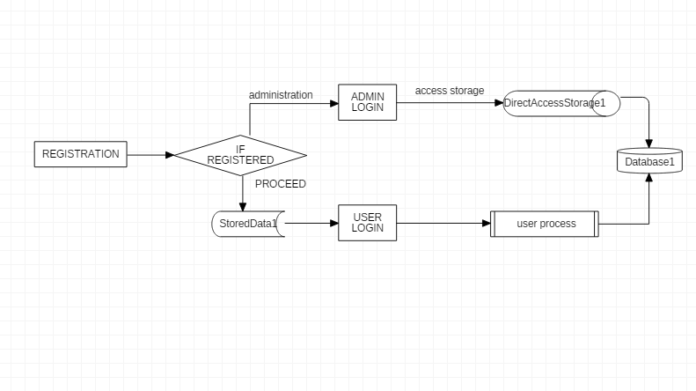

0 level DFD Diagram.

**1 level DFD Diagram:-**

The level 1 of Data flow diagram Represents the Internal Structure of Diagram through flow of data. It used to Show the light description of project Flow.

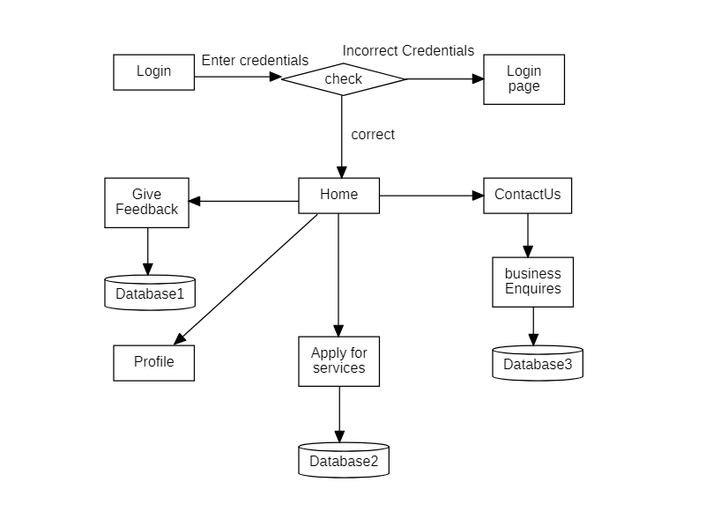

1 level DFD Diagram.

**4.4 Flow chart diagram:-**

A flowchart diagram is a diagram that depicts a process, system or computer algorithm. They are widely used in multiple fields to document, study, plan, improve and communicate often complex processes spelled as Flow charts, use rectangle, ovals, diamonds and potentiality numerous other shapes to define the types of step, along with connecting arrows to define flow and Sequence.

Flowchart are sometimes called by more specialized names such as process Flowchart, process Map, Function flowchart, Business process Mapping. Business Process modeling and Notation (BPMN), or Process Flow diagram (PFD). They are related to other popular diagrams, such as Data Flow Diagram.

As visual presentation of data flow, flowcharts are useful in writing a program or algorithm and explaining it to others or collaborating with them on it. You can use Flowchart to spell out the logic behind a program before ever starting to code the automated process. It can help to organize big-picture thinking and provide a guide when it comes time to code. Specifically, Flow chart can:

* Demonstrate the way code is recognized.
* Visualize the execution of code within a program.
* Show the Structure of a website or application.
* Understand how users navigate a website or program.

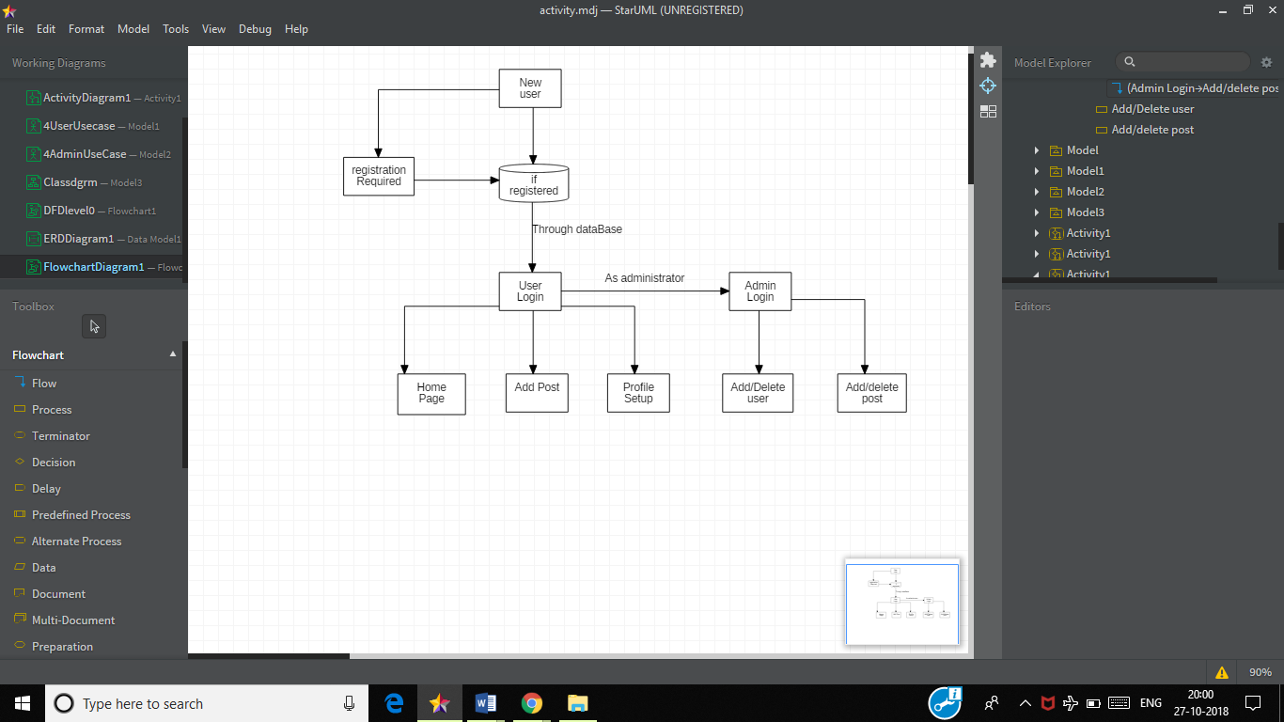

Flowchart diagram

**4.5 Activity Diagram:-**

Activity Diagram is another important behavioral diagram to describe dynamic aspects of the system. Activity diagram is essentially an advanced version of flow chart that modeling the flow from one activity to another activity.

Activity diagram describe how activities are coordinate to provide a service which can be at different levels of abstraction. Typically, an event needs to be achieved by some operations, particularly where the operation is intended to achieve a number of different things that require coordination, or how the events in a single use case relate to one another, in particular, use cases where activities may overlap and require coordination. It is also suitable for modeling how a collection of use cases coordinate to represent business workflows.

Activity diagram notation summary:-

Activity

Is used to Represents a set of action

Action

It represents a task to be performed.

Show the sequence of execution.

Initial node - portrays the beginning of a set of actions or activities

Final Node - Stop all control flow and Object Flows in an activity.

Activity Diagram:-

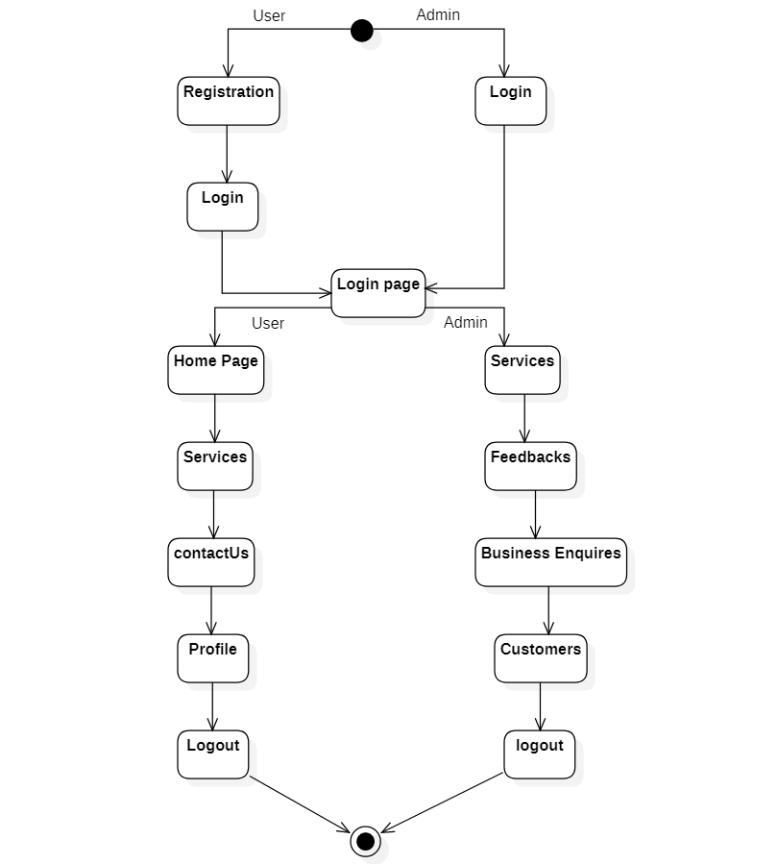

**4.6 Class Diagram:-**

Class diagram are one of the most useful types of diagram as they map out the structure of a particular system by modeling its classes, Attributes, operations, and relationship between object.

Class diagram offer a number of benefits for any organization. Use class diagram to:

* Illustrate data models for information systems, no matter how simple or complex.
* Better understand the general overview of the Schematics of an application.
* Visually express any specific needs of a system and disseminate that information throughout the business.
* Create detailed charts that highlight any specific code needed to be programmed and implemented to the described structure.
* Provide an implementation-Independent description of types used in a system that are later passed between its components.

Basic component of a class diagram:

The standard class diagram is composed of three sections:

* Upper class: Contains the name of the class. This section is always required, whether you are talking about the classifier or an object.
* Middle section: Contains the attributes of the class. Use this section to describe the qualities of the class. This is only required when describing a specific instance of a class.
* Bottom section: Includes class operation (methods). Displayed in list format, each operation takes up its own line. The operations describe how a class interacts with data.

Member access modifiers

All classes have different access levels depending on the access modifier (visibility). Here is the access level with their corresponding symbols.

* Public (+)
* Private(-)
* Protected(#)

Member scope: Classifiers and Instances.

Classifiers are static member while instance are the specific

Instance of the class.

**Class diagram:-**

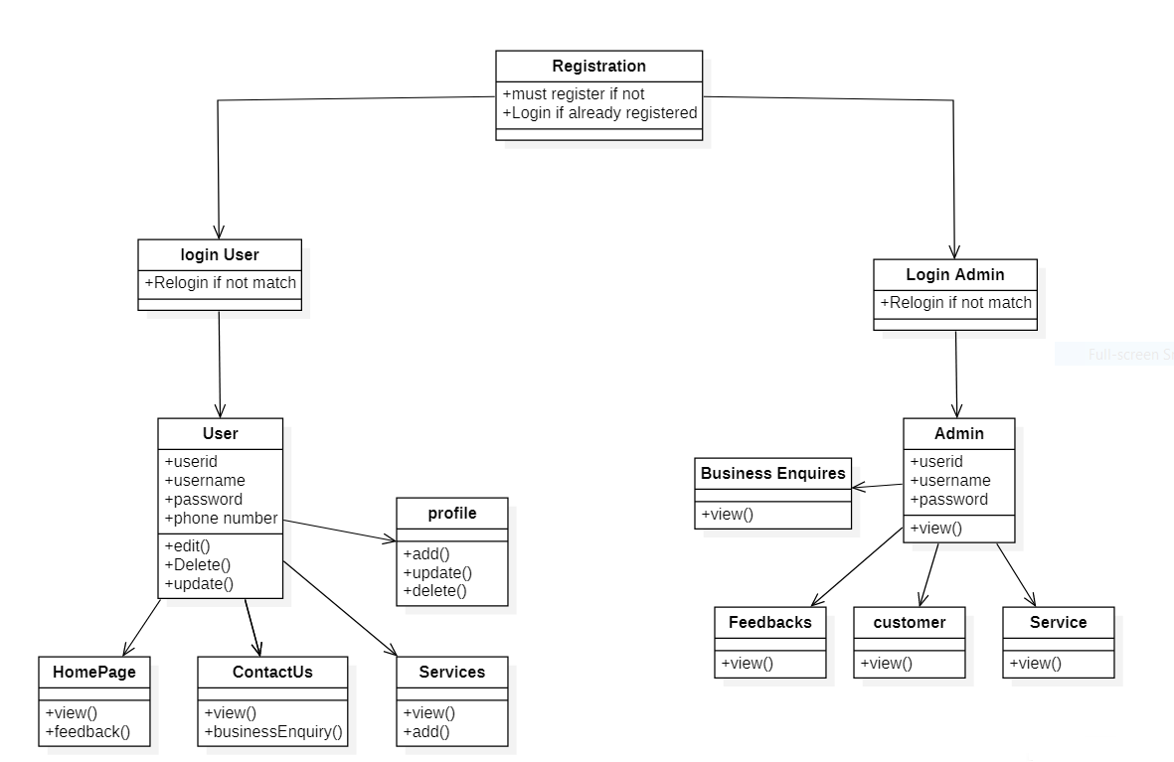

**4.7 ER- Diagram:-**

An entity relationship diagram s a type of a flowchart that illustrate how “entities” such as people, objects or concepts relate to each other within a system. ER diagram are most often used to design or debug relational database in the fields of software engineering, business information system, education and research. Also known as ERDs or ER models, they use a defined set of symbols such as rectangle, diamonds, oval and connecting lines to depict the interconnectedness of entities, relationship and their attributes. They mirror grammatical structure, with entities as nouns and relationships as verbs

ER diagram are related to data structure diagram (DSDs), which focus on the relationships of element themselves. ER diagram also are often used in conjunctions with data flow diagrams (DFDs), which map out the flow of information for process or system. Use of Entity Relationship diagram:-

* **Database Design:-** ER diagram are used to model and design relational databases, in terms of logic and business rules (in a implemented in a physical data model.) in software engineering, an ER diagram is often an initial step in determining requirements for an information system projects.

* **Database Troubleshooting:-** ER diagram used to analyze existing database to find and resolve problem in logic or deployment.
* **Business Information systems:-** The diagram are used to design or analyze relational database used in business processes. Any business process that uses fielded data involving entities, actions and interplay can potentially benefit from a relational database. It can streamline processes, uncover information more easily and improve results.
* **Education:-** Database are today’s method of storing relational information for educational purpose and later retrieval, so ER Diagrams can be valuable in planning those data structures.

The component of an ER diagram:- ER diagram are composed of entities, relationship, and attributes. They also depict cardinality, which defines relationships in terms of numbers

* **Entity:-** A definable thing – such as person, object, concept or event-that can have data stored about it. Think of entities as nouns .e.g. a customer, student, car or product. Typically shows as a rectangle

Entity

* **Relationship**

How entities act upon each other or are associated with each other. Think of relationships as verbs. For example, the named student might register for a course. The two entities would be the student and the course, and the relationship depicts is act of enrolling, connecting the two entities in that way. Relationships are typically shown as diamonds or labels directly on the connecting lines.

Relationship

**ER diagram:-**

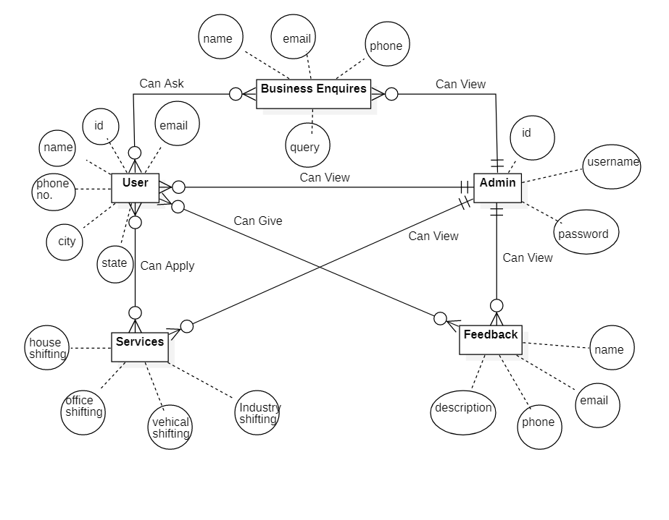

**4.8 Gantt charts:**

* A Gantt charts is constructed with a horizontal axis representing the total time span of the project, broken down into increments (for example, Days, Weeks, or months) and a vertical axis representing the tasks that make up the project (for example, if the project is outfitting your computer with new software, the major tasks involved might be: conduct research, choose software, install software). Horizontal bars of varying lengths represent the sequence, timing, and time span for each task.
* Gantt charts give a clear illustration of projects, but one problem with same is that they don’t indicate task dependencies- you cannot tell how one task falling behind schedule affects other task.
* Automated Gantt charts store more information about tasks, such as the individuals assigned to specific tasks, and notes about the procedures. They also offer the benefit of being easy to change, which is helpful. Charts may be adjusted frequently to reflect the actual status of project tasks as, almost inevitable; they diverge from the original plan.
* Gantt charts are method to planning tool that can be used to represents the timing of task required to complete a project.
* Gantt charts are simple to understand and easy to construct.
* In a Gantt charts, each task takes up one row. Date run along the top in increment of days, weeks or months, depending on the total length of the project.
* The expected time for each task is represented by a horizontal bar whose left end marks the expected beginning of the task and whose right end marks the expected completion date.
* As the project progresses, the chart is updated by filling in the bars to a length proportional to the fraction of work that has been accomplished on the task.
* Complete task lie to the left of the line and more completely filled in. Current tasks cross the line and are behind schedule if their filled -in section is to the left of the line and ahead of schedule if the filled-in section stop to the right of the line.

**Screenshots:**

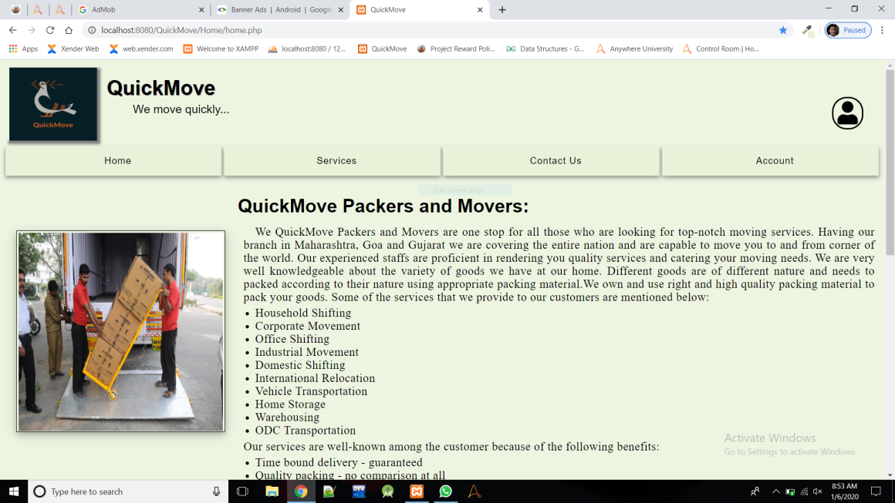

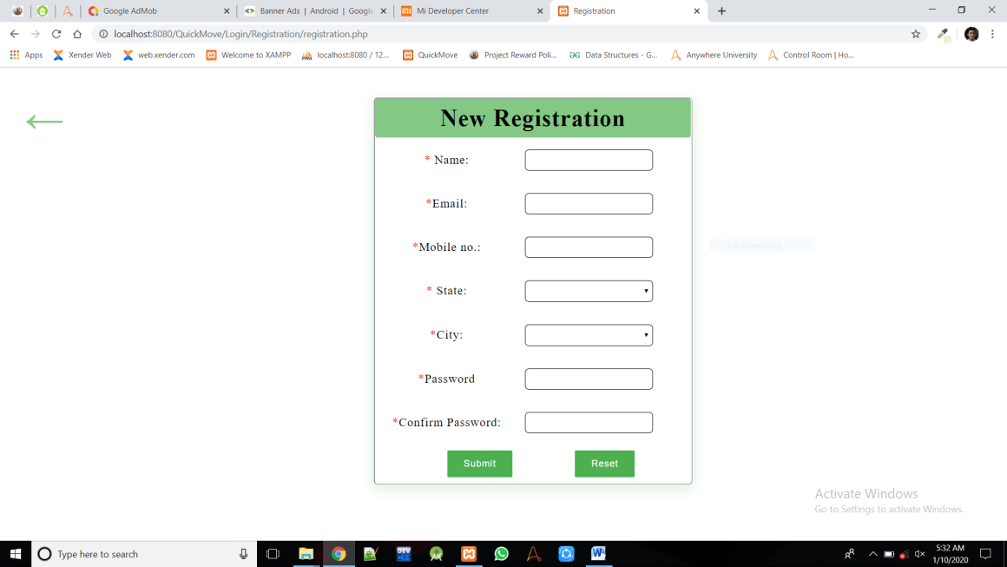

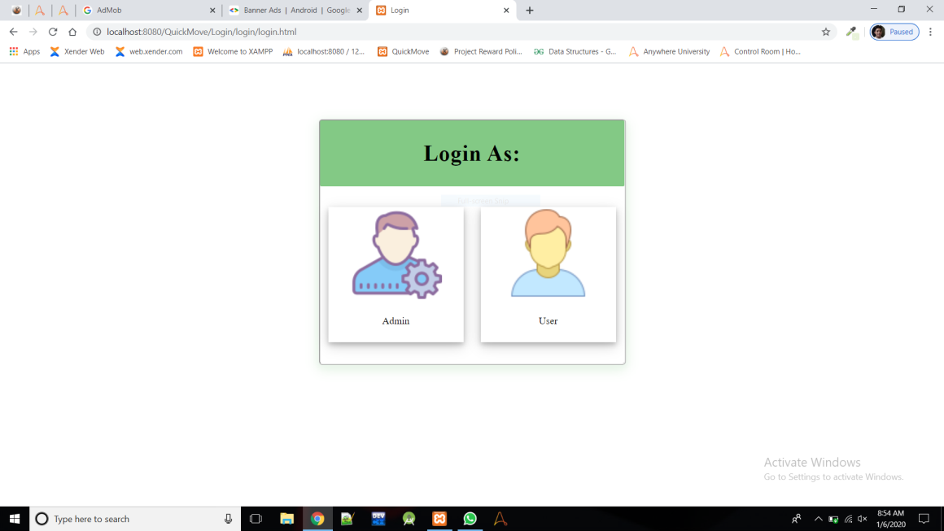

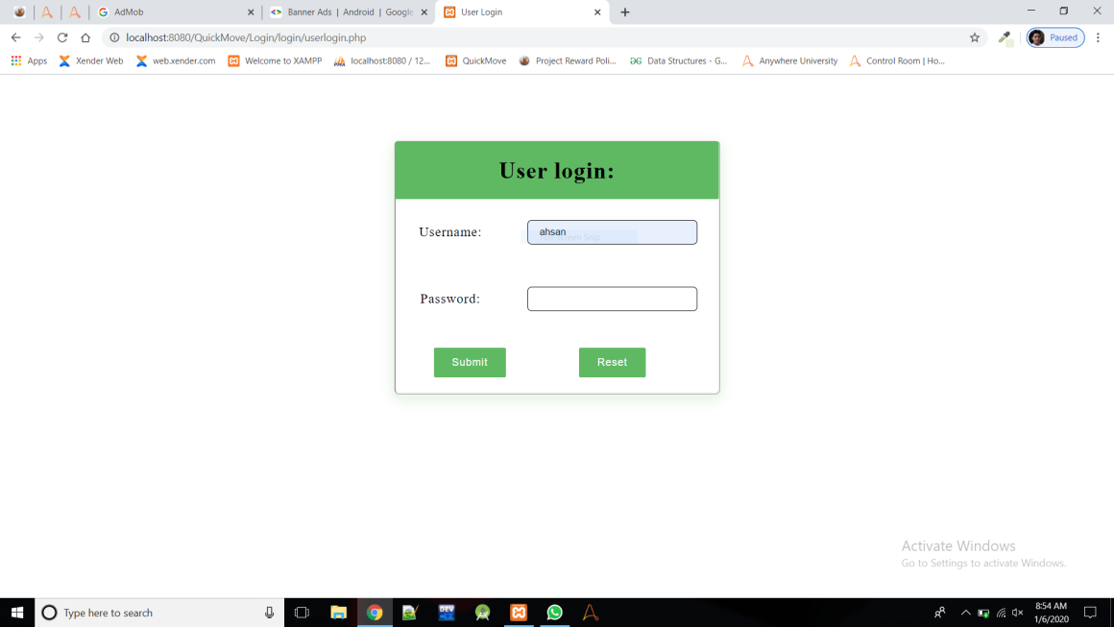

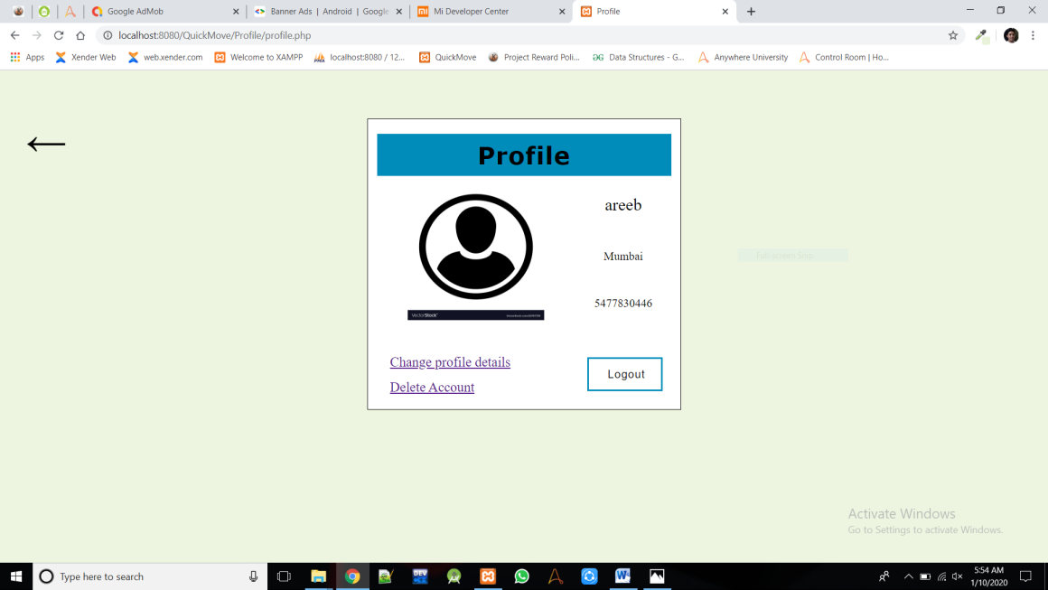

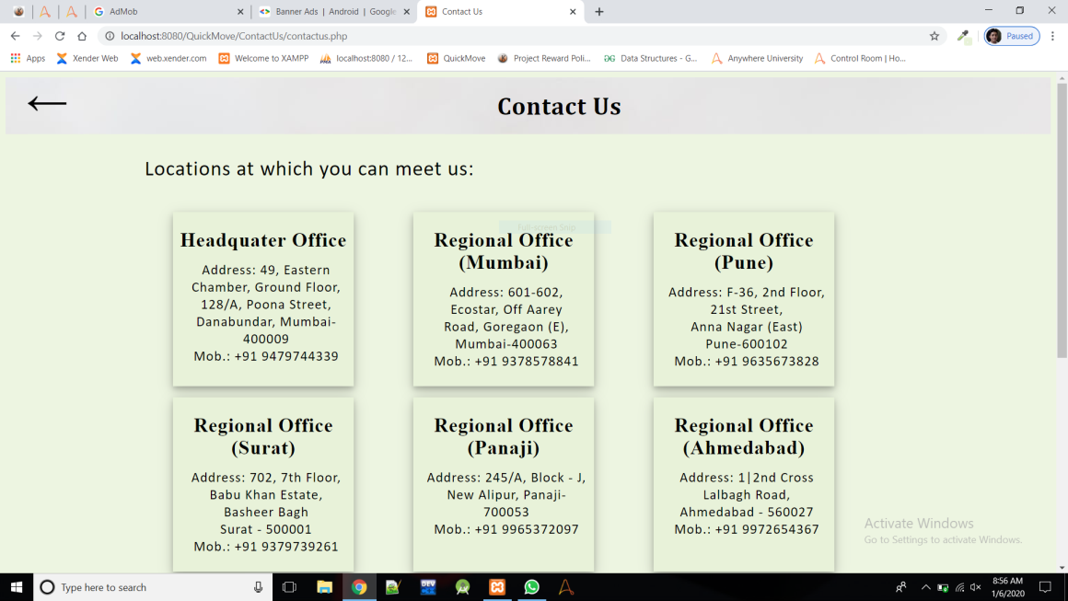



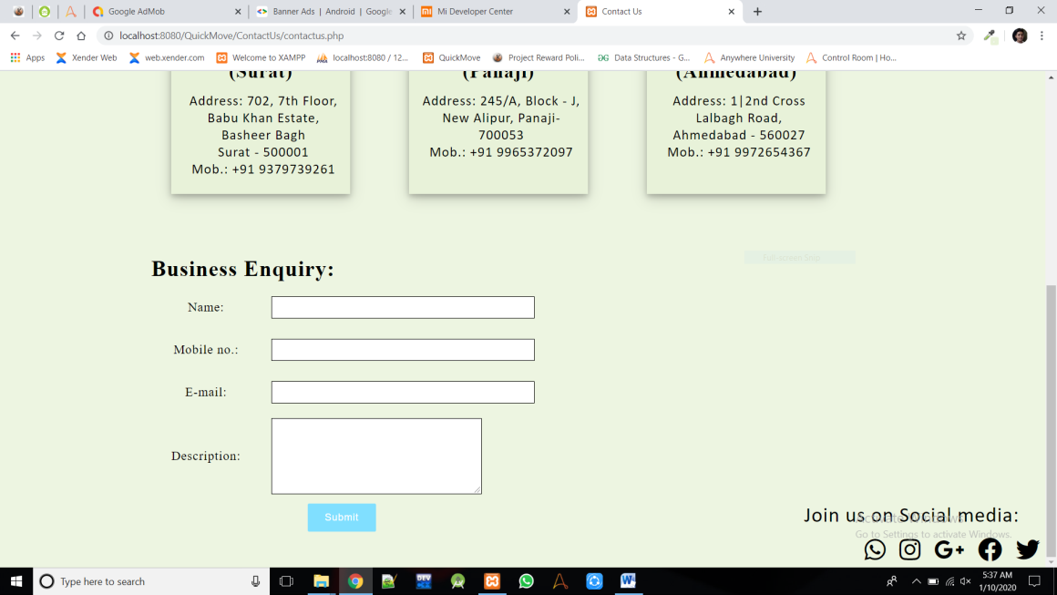

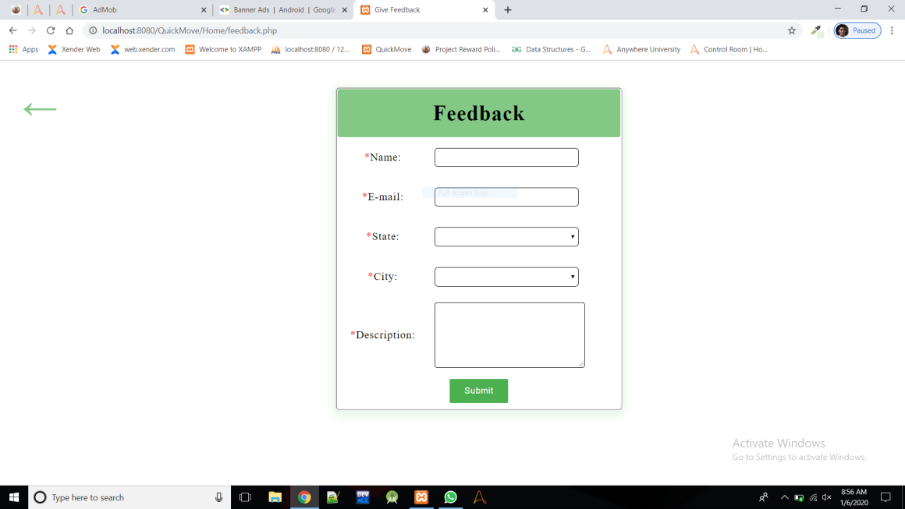

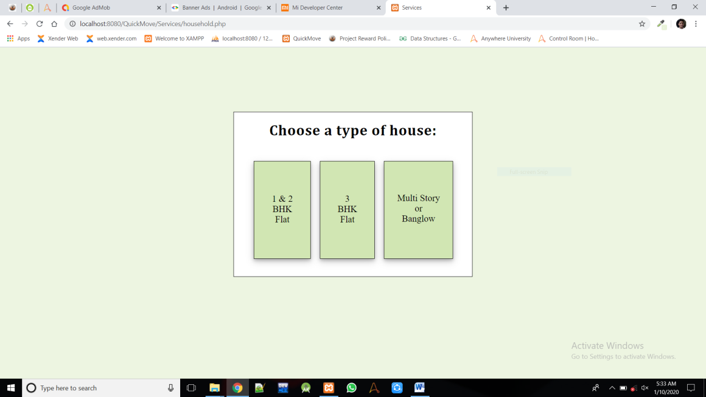

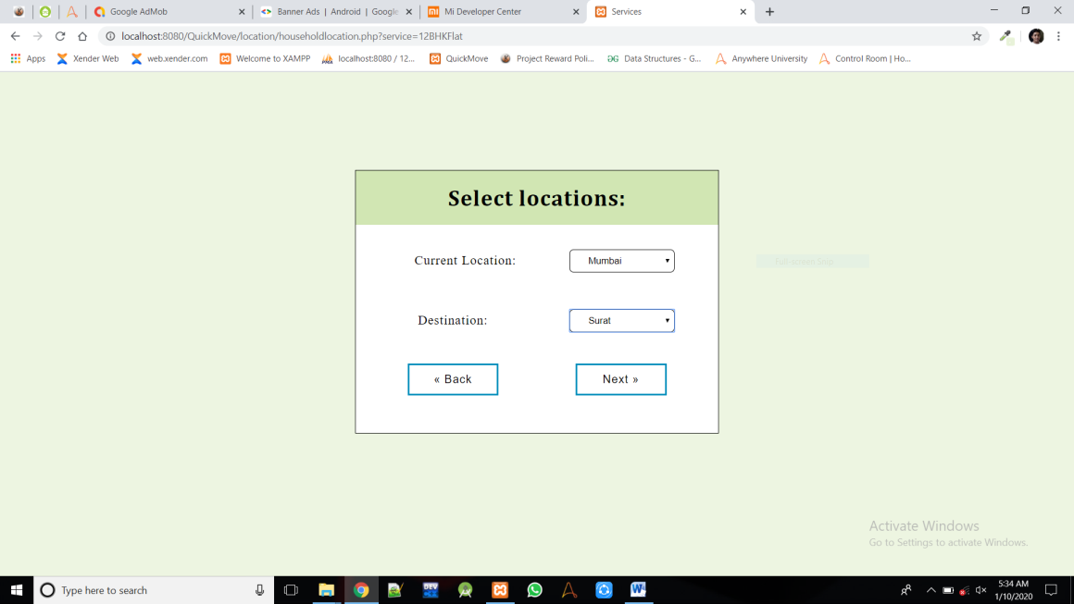

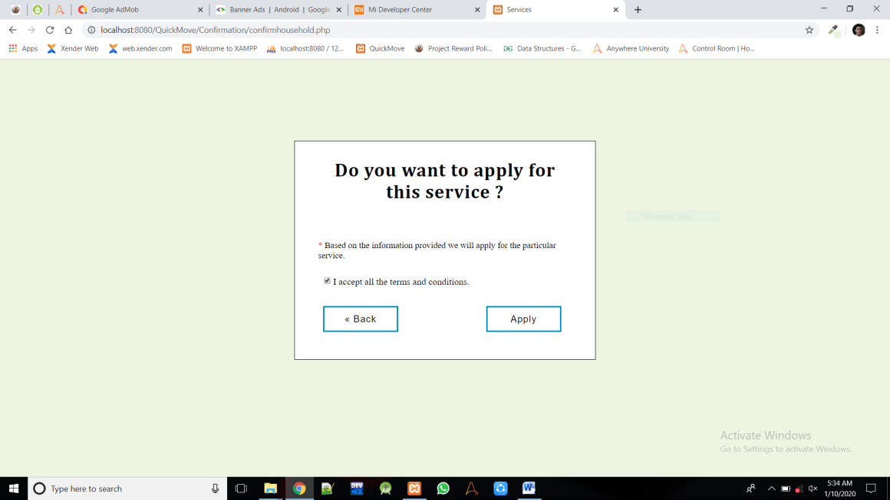

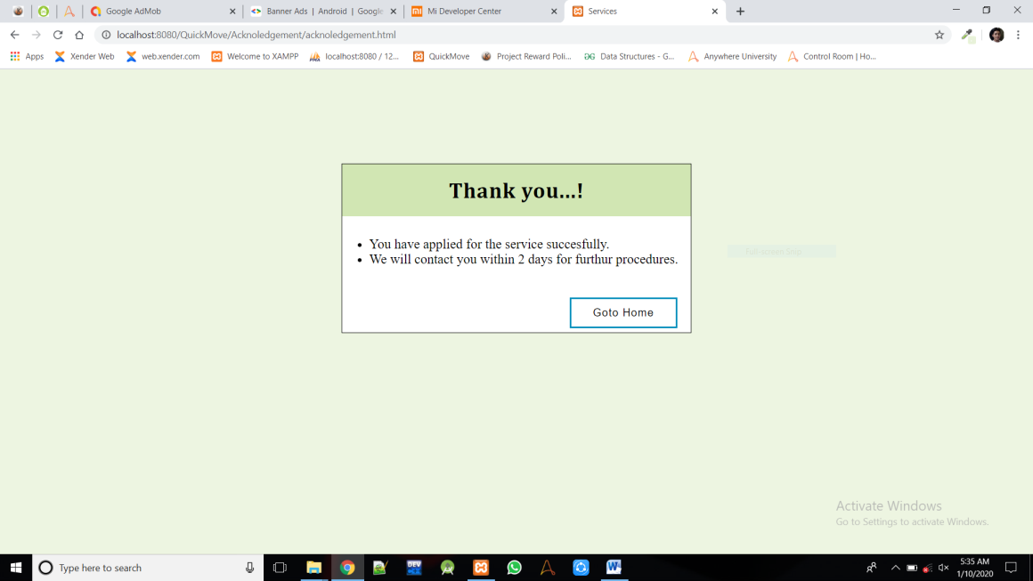

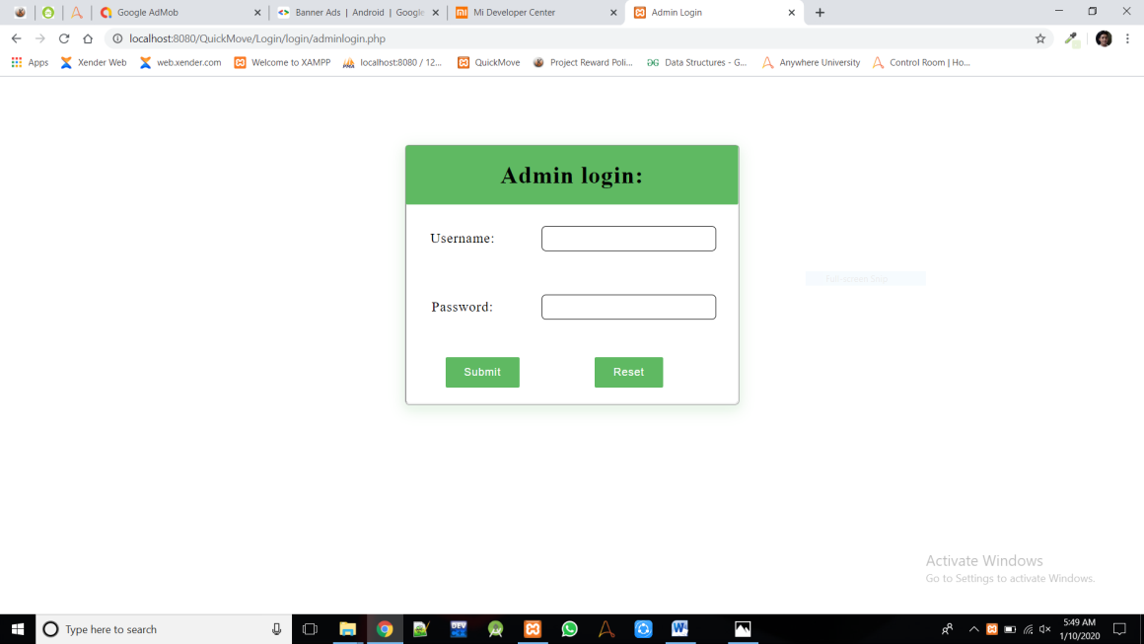

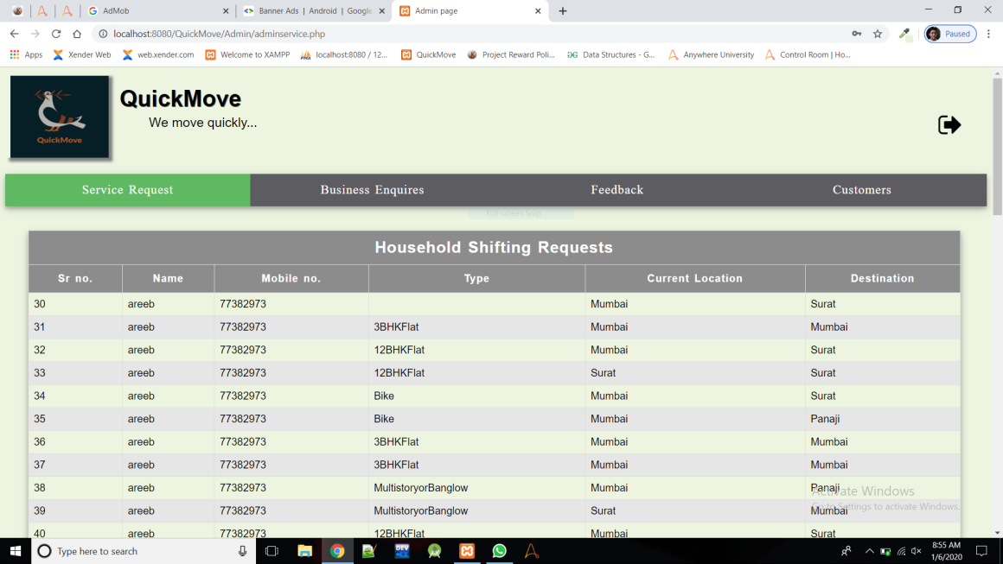

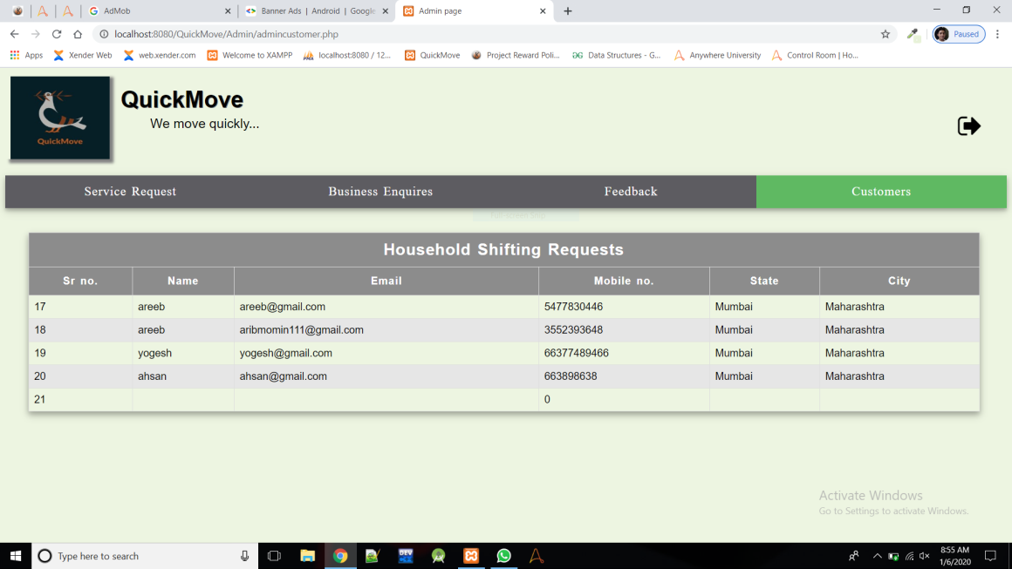

**Database Screenshots:**

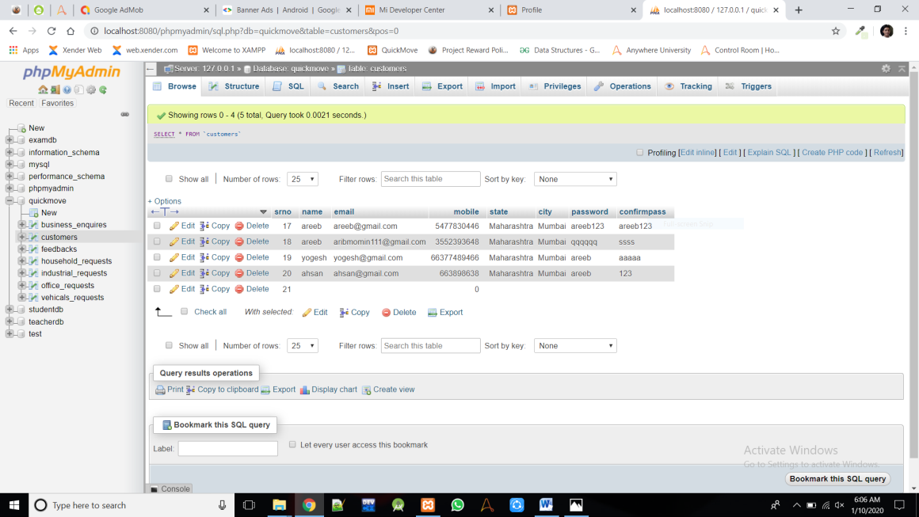

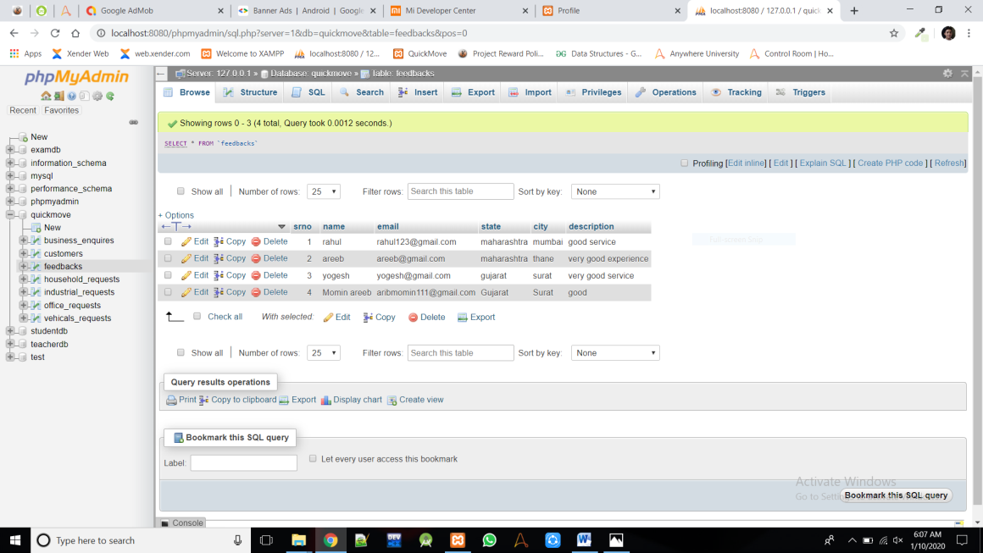

**Software Testing Strategies**

Testing is a set of activities that can be planned in advanced and conducted systematically. A strategy for software testing must accommodation low-level tests that are necessary to verify that a small source code segment has been correctly implemented as well as high-level tests that validate major system functions against customer requirements

There are three types of testing strategies

1. Unit test
2. Integration test

3. Performance test

**Unit Testing:**

Unit testing focuses verification efforts on the smallest unit of software design module. The unit test is always white box oriented. The tests that occur as part of unit testing are testing the module interface, examining the local data structures, testing the boundary conditions, execution all the independent paths and testing error-handling paths.

**Integration Testing:**

Integration testing is a systematic technique or construction the program structure while at the same time conducting tests to uncover errors associated with interfacing. Scope of testing summarizes the specific functional, performance, and internal design characteristics that are to be tested. It employs top-down testing and bottom-up testing methods for this case.

**Performance Testing:**

Timing for both read and update transactions should be gathered to determine whether system functions are being performed in an acceptable timeframe.

**Conclusion**

The main objective of the project is to automate the "Packers and Movers" by using MY-SQL back-end and HTML, CSS as front-end and PHP as server-side technology under Windows environment. QuickMove packers and movers is an effective and easy to use tool. It is a quick response application that can store each detail of every services applied, feedback given, business enquires, user information in the database. There is always space for improving in any software package, however good and efficient it may be. But the important thing is that the system should be flexible enough for future modifications. Reliable and accurate reports are generating, which is not possible into existing system.

**Bibliography**

BOOKS AND MANUALS:-

• AN INTRODUCTION TO DATABASE SYSTEM

AUTHOR- BIPIN C. DESAI

• SOFTWARE ENGINEERING

AUTHOR- R. PRESSMAN

• SYSTEM ANALYSIS AND DESIGNING (SAD)

IGNOU REFERENCE BOOKS

• http://www.google.com